# Q1 Power subsystem [30]

## Q1.1 Specification [10]

The submodule must be able to receive 5v via a USB micro-B male connector.

the power of the subsystems is supplied by a 3.7V li-ion battery.

The battery is mounted on the PCB via an 18650 connector.

The Battery Charging Circuit (MCP73831)

Input Voltage: 3.75 v to 6 V

Charge Curent : 15 mA to 500 mA

Temperature Range: -40°C to +85°C

Output Voltage: 4.2V

Reverse Discharge Protection

Supply current: 510 to 1500 µA when charging.

Supply current: 53 to 200 µA when Charge Complete, No Battery

Voltage Regulator (LM3670MF-3.3/NOPB)

The lithium battery supplies the microcontroller with a 3V3 Voltage trough a Voltage Regulator

Input Voltage: 3.6 V to 5.5 V

Fixed Output Voltage: 3V3

Max load: 350-mA

Battery Under-voltage cutout protection

Cut off Voltage: 2.98 V.

The UVLO is circuit has a LT1495 V Op ams, A406407 Mosfet, LT1389 Zener Diode and 6 resistors (R1=3.6M, R2=3M, R3=2.5M, R4=150k, R5=1M, R6=10M)

The UVLO circuit is designed to consume as low power as possible hence the use of very large resistance values that draw very small current.

* The submodule must be able to receive 5v via a USB micro-B male connector
* the power of the subsystems is supplied by a 3.7V lithium battery.
* The battery is mounted on the PCB via an 18650 connector.
* The lithium battery charging circuit is supplied by a 5-v supply.
* The 5v Voltage is reduced to 4.2v using MCP73831 Chip which charges the battery.
* The charging of the battery is indicated by a Red Led.
* The lithium battery supplies the microcontroller with a 3V3 Voltage trough a Voltage Regulator.
* The voltage regulator LM3670MF-3.3/NOPB regulates the input voltage of range from 3.6 to 5.5 to a fixed 3.3V values.
* One the battery voltage goes below 2.98V the UVLO will stop the battery from supplying power to the microcontroller, this is done to prevent a deep discharge of the battery.
* The UVLO is circuit has a LT1495 V Op ams, A406407 Mosfet, LT1389 Zener Diode and 6 resistors (R1=3.6M, R2=3M, R3=2.5M, R4=150k, R5=1M, R6=10M)
* The UVLO circuit is designed to consume as low power as possible hence the use of very large resistance values that draw very small current.
* The power Subsystems is Protected by a Reverse Polarity Protection with a A06407 Mosfet.

## Q1.2 Draft Bill Of Materials (BOM) [10]

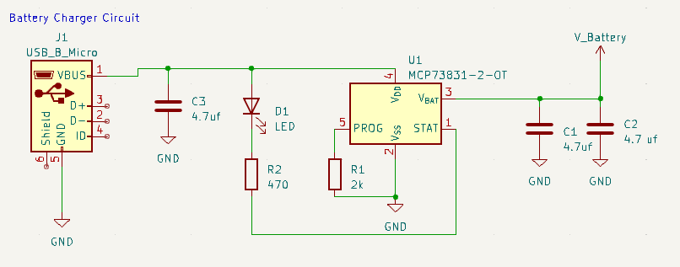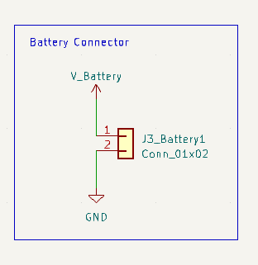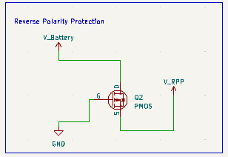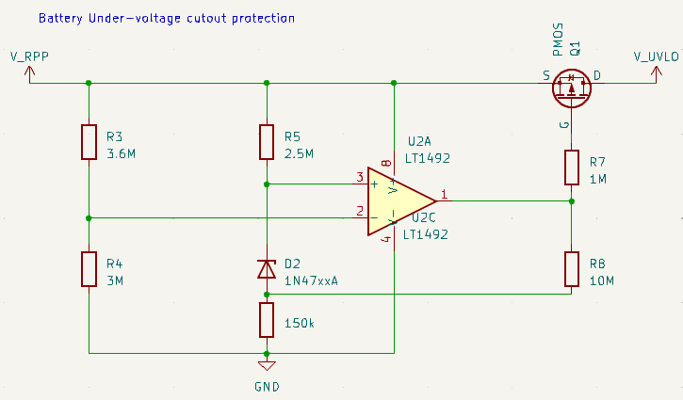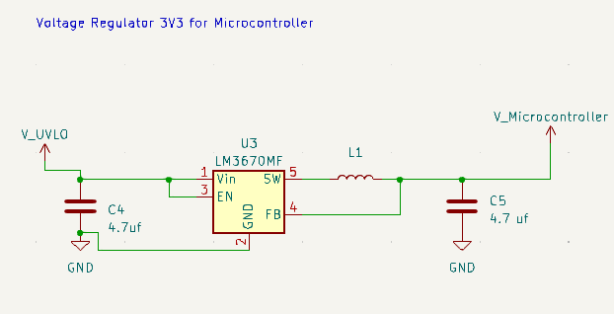

## Q1.3 Define this submodule’s interface(s) [10]

# Q2 Microcontroller interfacing [30]

## Q2.1 Specification [10]

This submodule consists of three female connectors, two for comms and 1 for the sensors.

We have a female connector that connects to the SPI pins of the stm32 and a female connector that connects to the I2C pins of the stm32.

A DAC input output for our direct analogue signal.

## Q2.2 Draft Bill Of Materials (BOM) [10]

Link to the spreadsheet:

<https://gitlab.com/group-228234308/3088f-repo/-/blob/main/Intergration/Book1.xlsx>

Total anticipated cost:

$4.00

## Q2.3 Define this submodule’s interface(s) [10]

This submodule interfaces with an analogue and a digital sensor connected through a female connector.

The analogue sensor reading a sent directly to the STM’s DAC through the DAC output.

There is an SPI output and an I2C for communicating the data received from the digital sensor to the STM.

The CPU controls the flow of data.

**Q3 Sensing**

Q3.1 Specification

3.1.1 Digital Sensor Specification:

The digital sensor in this case is a TMP101NA/3K which is a temperature sensor from Texas Instruments. Here are its specifications and power consumption range:

Specifications:

* Temperature measurement range: -55°C to +125°C
* Accuracy: ±1°C (maximum) from -10°C to +85°C
* Resolution: 0.0625°C
* Operating voltage range: 1.4V to 3.6V
* Interface: I2C
* Package: SOT-23-6

Power Consumption Range:

* Supply current: 50µA (maximum)
* Shutdown current: 0.1µA (maximum)
* Operating current: 210µA (maximum) at 3.3V supply voltage, continuous conversion mode
* Note that the power consumption can vary depending on the specific operating conditions and configuration of the sensor.

3.1.2 Analog Sensor Specification:

The analog sensor in this case is MCP9700T-E/LT which is a low-cost analog temperature sensor from Microchip Technology. Here are its specifications and power consumption:

Specifications:

* Temperature measurement range: -40°C to +125°C
* Accuracy: ±2°C (maximum) at 25°C
* Output voltage range: 0.4V to 2.0V
* Sensitivity: 10mV/°C
* Operating voltage range: 2.3V to 5.5V
* Interface: Analog
* Package: SC-70-5

Power Consumption:

* Supply current: 6µA (typical) at 3.3V supply voltage, operating mode
* Shutdown current: 1µA (maximum)

Q3.2 Draft Bill of Materials (BOM)

Digital Sensor

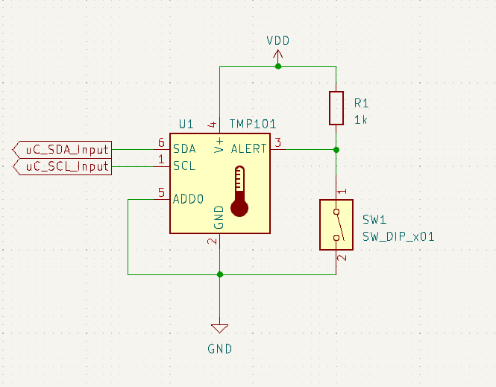

Analog Sensor

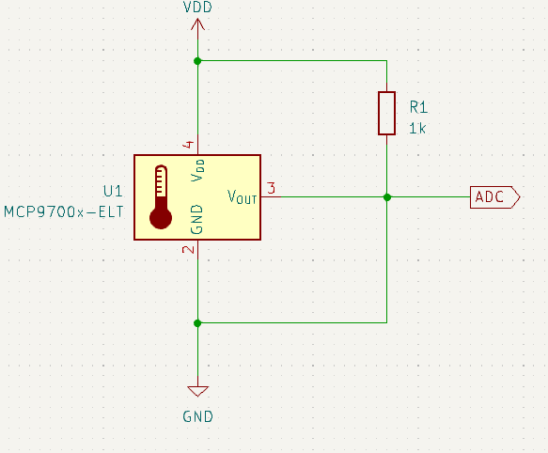

Link to Spreadsheets on gitlab: [spreadsheet](https://gitlab.com/group-228234308/3088f-repo/-/tree/main/Sensors)

Total anticipated cost for digital sensor: $1,47

Total anticipated cost for analog sensor: $1,32

Q3.3 Define this submodule’s interface(s)

Q3.3.1 Digital Sensor Interface:

* Electrical Interface: The electrical interface of the TMP101NA/3k temperature sensor is through its supply voltage, ground, and I2C interface pins. The supply voltage should be between 1.4V and 3.6V. The I2C interface consists of the SDA and SCL pins, which are used for data transfer between the sensor and other modules in the system. The SDA and SCL pins should be connected to the corresponding pins of the microcontroller or other devices in the system. The electrical characteristics of the I2C interface include voltage levels, timing, and data format, which should be compliant with the I2C specification.
* Mechanical Interface: The mechanical interface of the TMP101NA/3k temperature sensor is through its package, which is a SOT-23-6. The package dimensions are 2.9mm x 1.6mm x 1.1mm, and it has six pins. The package can be mounted on a PCB using surface-mount technology or through-hole technology.
* Visual Interface: The TMP101NA/3k temperature sensor does not have any visual interface as it does not have any LED indicators or displays.
* Audible Interface: The TMP101NA/3k temperature sensor does not have any audible interface as it does not have any buzzer or speaker.
* Tactile Interface: The TMP101NA/3k temperature sensor does not have any tactile interface as it does not have any buttons or switches.

Q3.3.2 Analog Sensor Interface:

* Electrical Interface: The electrical interface of the MCP9700T-E/LT temperature sensor is through its supply voltage and output voltage pins. The supply voltage should be between 2.3V and 5.5V, and the output voltage ranges from 0.4V to 2.0V depending on the temperature measurement. The sensor provides an analog output voltage that can be read by an analog-to-digital converter (ADC) or other analog signal processing circuits in the system.
* Mechanical Interface: The mechanical interface of the MCP9700T-E/LT temperature sensor is through its package, which is a SOT-23-3. The package dimensions are 2.0mm x 1.3mm x 1.0mm, and it has three pins. The package can be mounted on a PCB using surface-mount technology or through-hole technology.
* Visual Interface: The MCP9700T-E/LT temperature sensor does not have any visual interface as it does not have any LED indicators or displays.
* Audible Interface: The MCP9700T-E/LT temperature sensor does not have any audible interface as it does not have any buzzer or speaker.
* Tactile Interface: The MCP9700T-E/LT temperature sensor does not have any tactile interface as it does not have any buttons or switches.